**Soldering Safety Guidelines:**

This document provides information regarding lead soldering and safety precautions that has to be taken by staff and students associated with AMRIS Facility.

**General safety Precautions:**

1. **Working with solder, flux and cleaners:**

* Use lead free or low-lead solder if possible.
* Do not flick or shed the solder on the floors/benches.
* Always wear eye protection to avoid solder debris.
* Wear gloves while soldering and wash hands with soap and water after removing gloves.
* Keeping cleaning solvents like flux cleaner and iso-propyl alcohol in dispensing bottles to avoid inhalation hazards.
* Read the manufacturer’s instructions and MSDS (Material Safety Data Sheets) for all materials before beginning work.

1. **Personal Safety:**

* Do not eat or drink around the soldering station area.
* In order to prevent burns from splashes of hot solder or other debris wear long sleeve shirts and pants while soldering.
* Avoid inhalation of soldering smoke/fumes. Keep the fume extractor as close as possible to the object where solder is applied.
* Do not forget to clean your work area with a wet wipe after soldering to avoid lead surface contamination.

1. **Soldering Iron safety:**

* Clean the soldering iron with lead-free tip cleaner.
* Do not touch the soldering iron tip. It’s very hot (720⁰F) and it will burn.
* Keep the cleaning sponge wet during use.
* Do not put down the soldering iron on the work bench.
* If not in use, rest the soldering iron on its stand.
* Turn of the soldering station before you leave.

1. **Electrical Safety and fire prevention:**

* Examine equipment for cracked cords before soldering.
* Prevent damage to electrical cords during soldering. Keep them away from heated tips.
* Become familiar with fire extinguisher location in the room.
* Work on a fire-proof or nonflammable surface that is not easily ignited.

1. **First Aid:**

* In case of burns, cool the affected area with cold water for 15 minutes.
* Get medical attention if the condition is severe.

1. **Waste Disposal:**

* Lead soldering is considered hazardous. Dispose the lead solder and dross in the container placed in each soldering station.
* The collection container should be labeled and the approved labels will be provided by

UF Environmental Health and Safety (EH &S).

* Only one dross container is allowed per station.
* The container must be kept closed at all times.
* Full containers must be dated and promptly removed from the soldering station. Arrange for removal by placing a request for hazardous waste-pick up using the following link.

[**http://www.ehs.ufl.edu/programs/chemrad_waste/forms/**](http://www.ehs.ufl.edu/programs/chemrad_waste/forms/)

1. **RF Lab staff responsibilities:**

* Clean your work benches every month with TSP based cleaners.
* Educate students about the safety procedures that must be followed while soldering.
* Set up a schedule to dispose the contents of dross containers every four months.
* Set up a date to clean the general RF lab area every four months.

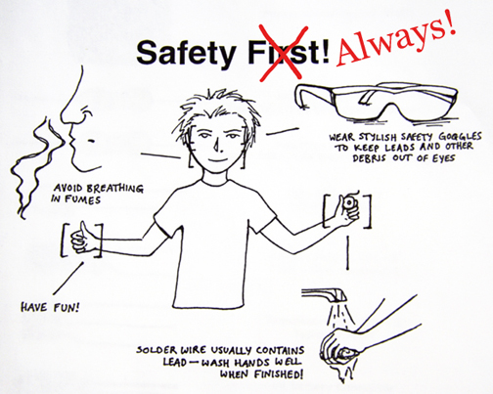 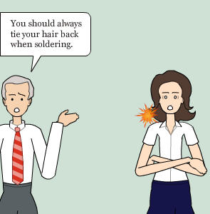

**Potential Hazards:**

**Fumes from Heated Lead solder:**

Lead is a known neurotoxin and can pose significant chronic health risk. Solder contain 37- 40 % lead and lead is considered toxic. If lead-containing solder is handled and treated properly, there is a minimal hazard to any person working with solder.

Potential exposure routes are:

* Ingestion of lead due to surface contamination.
* Skin contact with lead is harmless, but if you don’t wash your hands before eating you could be ingesting lead.
* The space under fingernails is great collectors of dust and dirt. So wash your fingernails and do not bite your fingernails.
* Soldering may produce fumes that are hazardous. The fumes can cause eye and upper respiratory tract irritation.

**Fumes from fluxes:**

Flux allows the solder to flow more smoothly. Soldering may involve the use of flux paste or liquid, or the solder itself may have a rosin core. When the flux is heated it converts to a gaseous or vapor state. There is a possibility that the person soldering is exposed to soldering fumes, if proper ventilation is not used. Even those who solder occasionally should make a habit to use fans or fume extractors.

The available types of flux in the market are:

* Rosin fluxes- Contact with rosin-based solder flux, flux residues, and the fume itself can cause dermatitis. Wear long sleeved clothing and gloves can prevent skin contact.
* Organic and Inorganic water soluble fluxes: These fluxes are lead free and toxic free. But they contain organic salts and acids which may produce mild allergic irritation of the skin and respiratory tract.

**Recommended Lead Work Practices:**

The OSHA Lead standard (CFR 1910.1025) addresses worker exposure to lead as an airborne contaminant. Based on standard soldering iron temperatures of 620⁰ F- 700⁰F and the melting point of lead (621⁰ F), with a vapor pressure of 0.0 mm Hg and a boiling point of 3164⁰F, **it is unlikely that lead fume will be generated during electronic soldering, unless the solder is heated to extreme temperatures.** Even when there is no exposure to lead fumes, there is still a need for safe work practices to prevent employee exposure to lead from other exposure routes described above.

For additional information or if you have exposure concerns, contact the Environmental Health and Safety (EH&S) office at 352-392-1591.