Dear Parent of Middle School Mentorship Applicant:
To protect the identities of all of our 18 and younger participants at the Magnet Lab, we are asking that you read and sign the following document.

I ________________________________, have reviewed my child's application and give my consent to the review of this application by the selection committee. I understand that if I do not sign below, my child's application is not applicable for review.
Please enter your child's name and sign below if you give consent for your child’s application to be reviewed
Your child's name: ______________________________________________________________

Your signature: _____________________________________ Date: ______________________

This signed document can be returned by scanning or photographing the document and returned by email to villa@magnet.fsu.edu.

Thank you,
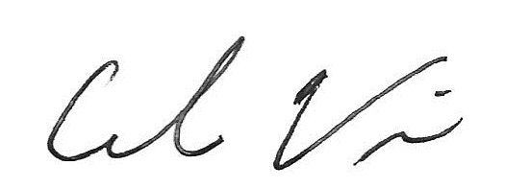
Carlos R. Villa

